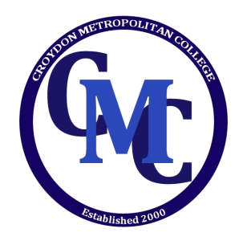
CROYDON METROPOLITAN COLLEGE

Part Time Course Application Form

PLEASE USE CAPTIALS

FIRST NAME:

LAST NAME:

ADDRESS:

POSTCODE:

SCHOOL: ____________________________________________ YEAR GROUP: ________________________

TEL/MOBILE: DOB:

PARENTS NAME/CONTACT NO:

Please tick below, the subjects you wish to study:

SUBJECT | 11+ | KS3 | GCSE | AS | A2
MATHEMATICS
PHYSICS
BIOLOGY
CHEMISTRY
ENGLISH

COMBINED SCIENCE

Any Other Subject(s) you may wish to study:

Where did you hear about Croydon Metropolitan College?

Terms and Conditions of Enrolment:

This enrolment form, when received by the Vice Principal, reserves a place at CMC.

The offer is valid only at the time it is made. Those wishing to accept the offer after some time must check with the Vice Principal that the place remains vacant.

- All fees for part-time group classes are payable monthly in advance at the first lesson of the month, failing that will incur additional administration charges of £10. (This does not include one off trial lessons charged at £20 for one hour)
- All part–time one to one classes are payable 24 hours in advance.
- Absence from classes for whatever reason, including sickness, does not automatically lead to a refund of fees under any circumstances.
- Cancellation of lessons must be made by 9am on the day of the lesson. Any lessons cancelled after this time will still be charged.
- Any physical or verbal abuse towards the staff will not be tolerated.
- Students are personally responsible for their own safety and are jointly or individually liable for any damage caused by them to the premises where they are taught.
- For classes with two students, if one student cancels, the lesson is still payable. Cancellation for classes with two students would also need to be made by 9am on the day of the lesson.

I have read the terms and conditions of Croydon Metropolitan College set out above and on the website www.croydonmet.org.uk. I agree to abide by them.

Name and Signature of person responsible for fees
Name: Date:
Signed: _______________________________________

© Croydon Metropolitan College 2019
A CENTRE OF ACADEMIC EXCELLENCE
30-32, SOUTHEND, CROYDON, SURREY, CR0 1DN
Tel: 02086885777 Fax: 02086885776
Email: admin@croydonmet.org.uk

